Dream Ecologies Worksheet
23rd November 2021 6:30pm
Maria Sledmere

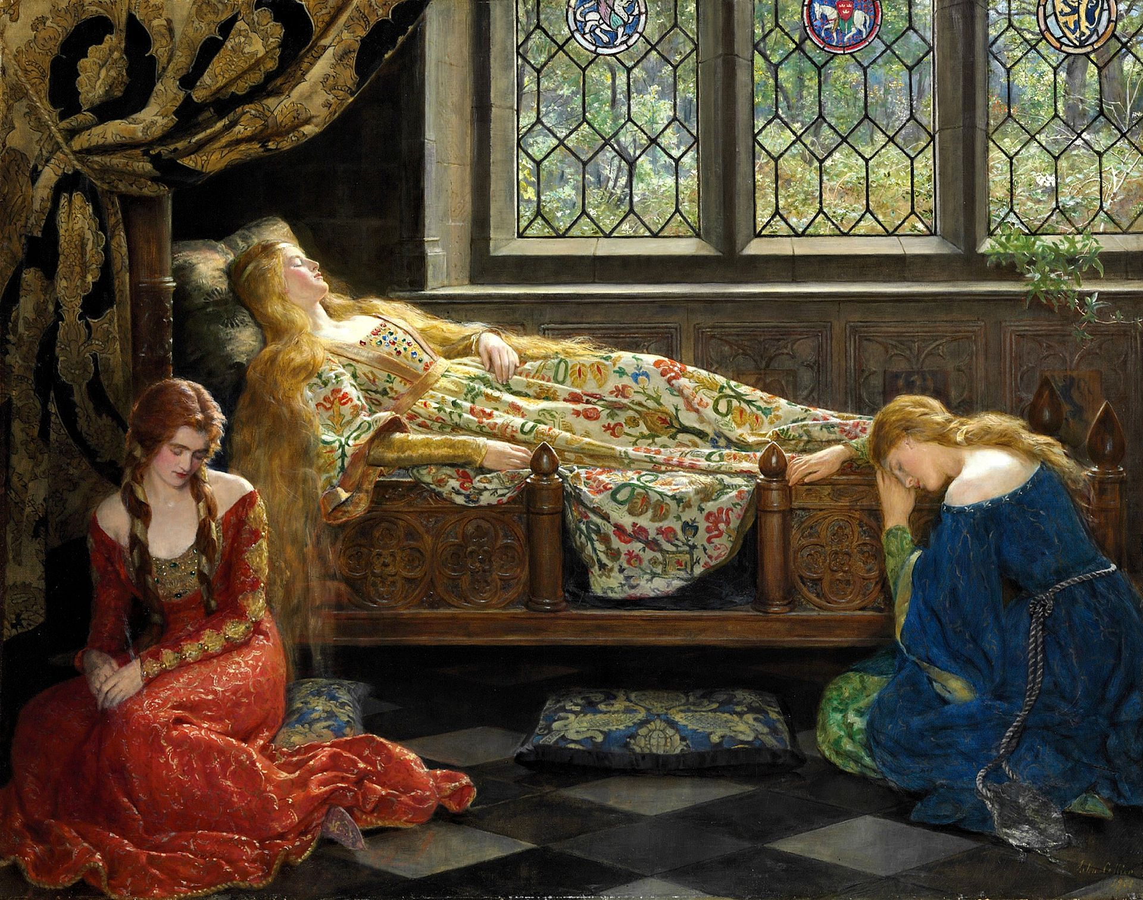
John Collier, Sleeping Beauty

I was lucky to be the dreamer because the dreamer never stops being interested. People know when they haven’t said enough, that’s why they dream. Or that’s not why they dream, but why they continue loving.
— Lauren Berlant

imagine touching your hand to your hand and knowing that you
and the whole world that you can perceive are the projection of a
dream machine made out of the sleeping minds of people whose
bodies look just like yours. what happens when they wake up? you
have to think. what and when am I really? you must wonder. how did
their dreams make rooms to dream in? whence their peaceful bodies,
whence their instantly activating minds?
— Alexis Pauline Gumbs, M Archive: After the End of the World
Before this workshop:
You might want to begin by keeping a dream journal. As soon as you wake up, get into the habit of writing down your dreams. Begin to notice patterns and recurring figures. Make a list or diagram of ecological or ‘Natural’ encounters that recur in your dreams. Ask friends or family what kinds of animals or landscapes tend to appear in their dreams. If you would like a more in-depth guide to preparing yourself for dreaming, and getting into the habit of dream-writing, you might want to check out this DREAMPAK from A+E Collective. No further prep is required.

Intro: (10 mins)
In The Four Seasons, Brandon Brown writes: ‘Now I think there is noth- / ing so beautiful as sleep, distributed hibernation in minia- / ture. Especially when the dreams are good’. Sleep is an essential feature of our circadian rhythms, a place of arrival and departure, an altered state, a recovery zone, the chilly sea in which the biggest part of the Freudian iceberg, the unconscious, sits. In what way might dreams be ecological? Brandon Brown says that sleep is a form of ‘distributed hibernation’: a long season of respite from the workaday alertness of our lives, spread across many nights. What do we gather, build and grow in our sleep? In ecopoetics describes the ‘oikos’ of ecology’s house, who sleeps there with us, in the poem? Dreams are where we process the input of daily life — from advertising to books, social media and interaction — but also a kind of escape from that.

Dreams project into the future and also mediate our narratives of the past. Culture thinks in dreams, capitalism thinks in dreams, politics thinks in dreams. We have the American Dream of meritocracy, which Lauren Berlant says pushes us into a form of ‘cruel optimism’, where ‘ideologies of the good life, like classic novelistic narrative and Hollywood film, train you to be on the side of people wanting their objects’. If dreaming is often misused or directed towards harmful and consumerist ideology, how can ecopoetics reclaim the dream? In this workshop, we’re going to think through that special thing of ‘distributed hibernation in minia- / ture’ as it manifests in the poem, a little space of dreaming that can help attune us to better ecological relations and intimacies. We’ll look at:

- What kind of form does dreaming take in an ecopoem?
- How does dreaming help us to process ecological affects such as grief, anxiety, melancholy, empathy and joy?
- How can dreaming provide alternative forms of desire, worldbuilding and futurity to those set out by late-capitalism?
- How can the imaginaries of dream diversify and complexify the unique experiences of climate crisis, away from those offered to us by the apocalypse modes of, for example, disaster movies?
- How can dreaming help us with the ecological ‘arts of noticing’ (Anna Tsing) within everyday life?
- How is dreaming a form of ‘continue[d] loving’ in Lauren Berlant’s words?
- What are the potential social and collaborative elements of dream ecologies? How can we build an ecology of dreams together?

In short: dreams are empowering! See for example this poem by Diane di Prima:

REVOLUTIONARY LETTER #51

As soon as we submit
to a system based on causality, linear time
we submit, again, to the old values, plunge again
into slavery. Be strong. We have the right to make
the universe we dream. No need to fear ‘science’
grovelling
apology for things as they are, ALL POWER
TO JOY, which will remake the world.

Caveat: This workshop is primarily an ecopoetry workshop inspired by the possibilities of dreaming for remaking worlds; it is not intended to offer professional advice about dream analysis.

Warmup: (10 minutes)
- Write down a dream you remember having recently. Identify one ‘ecological’ feature of the dream: something about time, relationships, landscapes or the nonhuman. Share a sentence in the chat.
- Free association: go to randomwordgenerator.com and generate five words. I am going to give you two minutes to write freely in response to each one, building from the scenes you just described in your dream memory. If you are struggling, try writing about the opposite meaning of the word – this can help disentangle the binaries which structure our thinking around issues of ecology.
- Write a short poem which connects your dream to the free writing.

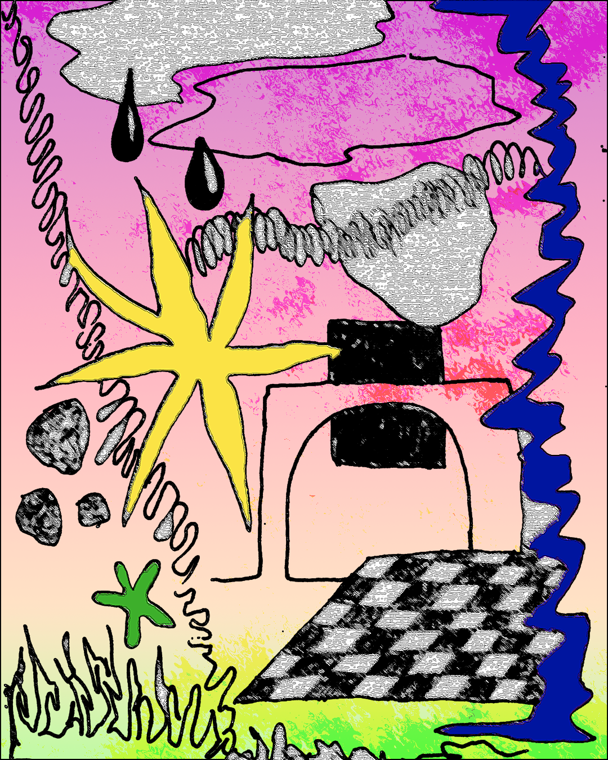
Maria Sledmere, 54:56

Dreams, Mediation and Colour (15 mins)
I am going to read for you a poem which includes elements of dreaming in relation to narrative, technology, place and language.

The Screen of Distance
Barbara Guest

1

On a wall shadowed by lights from the distance
is the screen. Icons come to it dressed in capes
and their eyes reflect the journeys their nomadic
eyes reach from level earth. Narratives are in
the room where the screen waits suspended like
the frame of a girder the worker will place upon
an axis and thus make a frame which he fills with
a plot or a quarter inch of poetry to encourage
nature into his building and the tree leaning
against it, the tree casting language upon the screen.

2

The telephone is Flaubert’s parrot and it flitters
from perch to perch across the city. Or someone
is holding the dead thing in her hand in a remote
hotel. A sensitive person with a disability who
speaks to the inanimate. She may even resemble
Louise Colet or the helpful niece. She hasn’t sent
her meaning and I am absent in these reminiscences
of her. The telephone is the guignol of
messages.

It may have been cold moving down from roofs,
a continental wind caught between buildings.
Leaves and pollen blowing onto fire escapes.
Windstruck hambones lying in a gutter. Equinoc-
tial changes the body knows, the hand feels, the
truck passes without notice and buildings con-
tinue their nervous commitments. The earth may
have been moaning underneath this junk. I am
caught in the wind’s draft.

3

At night viewing the screen of distance
with shadowy icons framed by light
I understood the rasping interior
was rearing other icons,

No longer gentle they flashed ripened clauses,
or images raised formidable projections of ice,
the wall was placed in a temporary position
where words glittered from a dark cover,

Narcissism lived in a silver hut.

4

In the lighter time of year words arrived
concealed in branches. Flaubert exchanged
himself for words, night became a night of
words and a journey a journey of words, and
so on.

Words became “a superior joke”, I trembled
under a revolutionary weight, a coward fleeing
from a cloud. The ego of words stretched to
the room’s borders assuming the sonorous
movement of a poem.

5

I entice this novice poem with a mineral, Beryl.
The dictionary bestows on Beryl a skittish description,

like a sequence in which a car
moves over ruptured roads and slices
into ghost veins of color—
a camera follows each turn,
examines the exits where rock protects
a visionary tool that prods it:—

“A light greenish blue that is bluer
and deeper than average aqua,
greener than robin’s eggs blue,
bluer and paler than turquoise
blue and greener and deeper than beryl
blue—a light greenish blue that is bluer
and paler than beryl or average turquoise blue—
bluer and slightly paler than aqua.”

The speculative use of mineral prevents an
attachment to words from overflowing, inserts
a vein of jazz, emblems of color and overcomes
the persecuting stretch of racetrack where words
race their mounts ....

6

Beryl became a distraction as one speaks of color
field or someone as a colorist or of color pre-
dominant, so the paper on which the poem would
rest was grainy with color flashing lights
and the depth, the deepness of the country lane
on which shadows found repose was a wilderness of
color, ditches and trees lost their contours. I
created a planned randomness in which color
behaved like a star.

7

To introduce color to form
I must darken the window where shrubs
grazed the delicate words
the room would behave
like everything else in nature,

Experience and emotion performed
as they did within the zone of distance
words ending in fluid passages
created a phenomenal blush
dispersing illusion ....

8

A difficult poem intrudes like hardware
decorating a quiet building, a tic taking
over the facade, a shrug exaggerated by a
column—

Shelley sailing into the loose wind,
the storm of neurosis hindering the formal plan,
a suggested dwelling left on the drawing board
with clumps of shrubs indicating hysteria or,

Daylight gleams on the rough street where a
blameless career sighs, the poet beak dips
in air, his little wings cause a mild stir,
as someone comes down the stair
he pleads with infancy,

A woman speaks to a dish, old forks, amid her
preparations she smiles touched by history.
Chipped, sundry evidences of temporal life
hiding in a bush. In formal dress domestic
remarks reel into a corpus known as stanzas.

9

The Bride raised the cloud settled on her
aspen head and stepping away from her bachelors
she seized like wands the poem I handed her:

“A life glitters under leaves
piled for anonymity ...”

She would lead us through glass to view the
enigmatic hill where a castle slung a shadow.

10

There was a dream within a dream and inside
the outer dream lay a rounded piece of white
marble of perfect circular dimension.
The dreamer called this marble that resembled
a grain of Grecian marble, “Eva Knachte,”
who was blown into the dream by the considerate
rage of night.

Her name evoking night became a marble pebble,
the land on which she rested was the shore
of the sea that washed over her and changed
her lineaments into classic marble, a miniature
being, yet perfect in this dream, her size
determined by the summer storm with which
I struggled and seized the marble.

The marble was a relic, as were the movements
of nature on the poem. The sea had lent
a frieze, waves a shoulder when the investitures
of a symbolic life feuded. In that dimness
with bristles, straw, armor plate, grotty
Alexandrines there appeared a mobile fiction ....

11

A man who calls himself a Baron yet strays from
his estate into the cadmium yellow
of a bewildering sunset rendered by apprehension
where a broad approach to a narrow tunnel
is fanned by leaves is faced with a decision—
at the stylized ominous entrance he wonders
if reality will maintain him or empathic snow
subdue his quest ....

12

I sifted through these fictive ambiguities
until there was a plain moment
something like a black table where

Dialogue set in motion urged a search
in memory for that tonal light
illuminating the screen,

The Baron faded as distance gleamed
a clear jar multiplied by frost.

Questions for this poem:
(feel free to unmute / raise hand / share points in the chat)
- What nonhuman forces such as weather, animals, technology, plantlife are present in this poem? What effects do they have on the speaker? What is their agency?
- What characters are discernible? Do they seem real to you?
- Is there anything dreamlike about the form of the poem?
- How does the poem explore space, time and ‘distance’?
- What can you discern about the voice and the speaker?
- What kinds of writing, mark-making, drawing or illusion-making happen in this poem?
- What do you think is the ‘screen of distance’?
- How does the speaker articulate the material environment or ecology of the poem?
- What effects does colour have on your sense of the poem?

Colour Writing (5 mins)
Go through the Dulux colour chart and select a colour. Make a list of everything ‘in Nature’ (which includes technology and objects!) where this colour can be found. Then incorporate your list into a poem which uses the colour as its title. Think about how the colour sets of different sensory associations and personalities, emotions, tones of expression. Organising your poem around colour can help tap into the more sensuous, associative and nonlinear forms of dream consciousness, as well as attuning to the expressions of your environment.

Crisis Dreaming
Reading: Jackie Wang (10 mins)
Dreams can help us process memories, trauma and identity by flipping perspectives or allowing us to experience the impossible: we can attend our own funerals, be present at the apocalypse, see ourselves from outside, be two people at once. How can poetry play with these logics for ecological effects or purposes?

Death as a Survival Technique
Jackie Wang
CW Warning: apocalypse, death, AIDS, sex

The world is warming, and we humans are to blame. In the future the world will only hold one person, therefore everyone else must die. It is for this reason that I find myself in a Hunger Games caused by global warming. Everyone knows there can only be one survivor. The people are febrile with murderous rage. Though I do not intend to kill anyone I still must persuade everyone not to kill me. I have to get them to empathise with me. But I don’t plead. Sometimes I hide by lying prone atop a pole pretending to be dead. By making myself visible I remove the anxiety of being found. My fake death becomes an orchestration that involves as many people as Tupac’s pseudo-death.

In the distance I hear Maxine eulogise me. He knows I’m not dead but to stop people from killing me he must convince them I have died. Feigning death makes me privy to how I will be remembered. I think, How sad that people are not alive to experience their funerals because it’s the most love they’ll ever get. Maxine memorialises people in a way that only a queer who has lived through the AIDS crisis can.
Ah, but I’m alive!
The threat of death calms me.
On the shore there is a crumbling beach house culled from the iconography of Eternal Sunshine of the Spotless Mind.
Everything is crumbling as we wait for intermittent waves to hit.
Where, in this house, will I find air to breathe?
The walls won’t hold. The safety I feel in this structure is false.
I am crouched in a corner waiting to die
Until Elijah comes and asks me to participate in a fashion show to “lighten the apocalyptic mood.”
Elijah takes me to a warehouse, dresses me in skimpy clothes and pushes me on stage.
Ashamed of my body, I try to cover myself with my hands and arms.
From the audience he yells, “Show more belly!”
And then to celebrate my performance he takes me into an empty crumbling house to play me a song on the piano while the house fills with water.
Imminent apocalyptic obliteration has brought out everyone’s repressed desires. All over the shore people are having BDSM sex in the ruins.
Where did all these leather belts come from, I think.
I see my friend all tied up, blissed-out, her eyes rolling back in her head.
It is a way to prepare for death.
The sadists believe they will be the ones who will survive.
The masochists embrace their powerlessness in the situation.
Freakish weather makes us all non-sovereign.
In this sense the sadists will be punished for their hubris: their belief that through sheer muscular will they can beat Mother Nature. The story becomes an epic showdown between sadists and masochists.
But I know that the situation calls for total passivity.
Maybe that doesn’t make sense?
Maybe it’s a pact with the gods.
The secret is to not try.
In giving yourself over to the inevitability of death, nothing can hurt you.
Nature no longer wants to kill you.
You have put yourself at the center of the battle of cosmic forces and lowered your sword.
Because you were willing to die, you will be spared.
But…
But.
I am sad that all my friends will die even if this situation has turned them against me.
Why must only one survive this environmental catastrophe?
To submit.
To take the passive road to heaven.
Survival of the fittest?
No.
Survival of the best at playing dead.

Questions
- How does this poem engage with stories and sensations of climate crisis?
- What is the effect of including names in this poem? Do you remember names from dreams?
- What is the difference between movies, poetry and dreaming as understood in the poem?
- How does the poem look to the future?
- What rhetorical or formal strategies (address, repetition, questioning, punctuation, syntax etc) does the speaker use to tell the dream?
- Was there anything about this poem that surprised you or didn’t make sense?

Exercise: (5 minutes)
Complete the sentence: ‘Survival of…’ as your prompt. Write a poem that tells the dream of this survival. Whose survival? What, when, where, how, why? Feel free to disregard ordinary logics of time, space, identity and sensation. You might want to use ‘Survival of’ as a repeating refrain (anaphora) in the poem, as a constraint. You also might want to imagine parts of the poem were forgotten upon waking, and practice some erasures on the finished product…a similar effect to how the poem would deteriorate when left out in the rain…

Nonhuman Dreaming (5 mins)
How do animals and other lifeforms dream? How might poetry help us imagine nonhuman sensoria?

Flush himself felt that it was impossible to lie still. Old longings revived; a new restlessness possessed him. Even his sleep was full of dreams. He dreamt as he had not dreamt since the old days at Three Mile Cross--of hares starting from the long grass; of pheasants rocketing up with long tails streaming, of partridges rising with a whirr from the stubble. He dreamt that he was hunting, that he was chasing some spotted spaniel, who fled, who escaped him. He was in Spain; he was in Wales; he was in Berkshire; he was flying before park-keepers' truncheons in Regent's Park. Then he opened his eyes. There were no hares, and no partridges; no whips cracking and no black men crying "Span! Span!" There was only Mr. Browning in the armchair talking to Miss Barrett on the sofa.
— Virginia Woolf, Flush (1933)

this is my perception—in words, in one word, you have the possibility of many dimensions, depending on how you use the word, on what intention you put into it. And this I believe is the same with the ani- mals: the animals relate to their own world on many levels too. There’s another study about the invention of theater by monkeys. And when you watch monkeys you can see that they know exactly how to trick, they know how to play, they know how to make fun. So all these levels are there. You look at these animals and there are certain moments when they are dreaming. It’s obvious that they are dreaming, it’s obvious that they have longings, too. A whole range of emotions and possibilities is there; it’s just that, somehow the simplifications of contemporary culture have allowed us to pretend that’s not the case.
— Cecilia Viçuna, in an interview with Jonathan Skinner for ecopoetics vol. 1

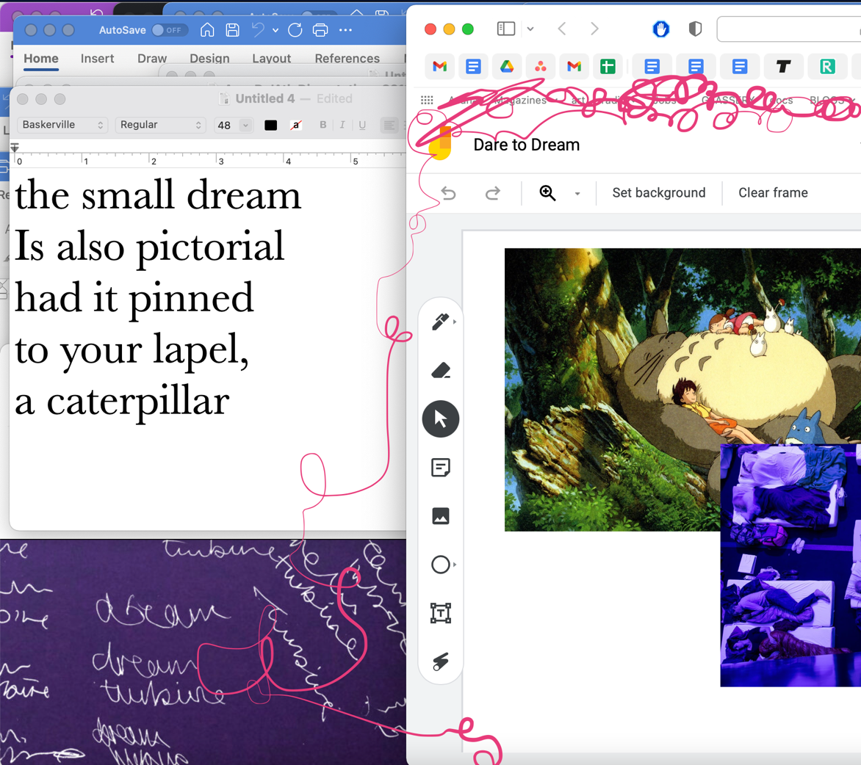
Maria Sledmere, Screenshot 16/11/21 (featuring materials from A+E Collective)

Exercise: (5 mins)
Choose an animal, plant, vegetable, mineral or other nonhuman entity, and write about their dreams in a poem — freely speculate and engage with different senses, timescales, voices. Try writing it as a dramatic monologue, a lyric fragment, a haiku — whatever seems appropriate to the creature/thing in question!

If you are stuck at this point, you could try visualising through drawing, collage or screenshots instead!

Social Dreaming (5 mins)
The concept of the dream retreat comes from the idea that our dreams are not only individual resources for our growth and development (though they are) they are also shared resources for our communities. Sometimes we dream about each other. Sometimes our dreams are in conversation. Almah taught me about groups of people who could know when a natural disaster was coming through the warnings in their collective dreams. I know that I have had the experience where even in a short workshop people started dreaming images and answers to other people’s situations in their dreams. I think sometimes we underestimate how interconnected we are as a species. So for the exact same reasons that we know that it is valuable for people of colour to come together to create solidarity and share insights and intentions, it is important for us to be intentional about how interconnected we are in our dreams. In chorus our dreams have whole new meanings and a lot of power.
— Alexis Pauline Gumbs

Social dreaming is a reflexive practice in which dreams and associated thoughts are shared in a way that brings forth possibilities for new perspectives and meanings about our wider social context.
— Mina Heydari Waite

Explain The Dream Turbine project with A+E Collective.

The Dream Turbine is at once a resource site and a generator of public engagement, ecological thought and re-visioning through the energising gestures of dreams. By encouraging attentive forms of dreamwork from the potential space of sleep, The Dream Turbine invites you into a mode of transfer, speculative turn, ongoingness and the tender commons of shared velocity. We’ve also made available a non-exhaustive list of dream inspiration/resources (including books, articles, films and music) where you can learn more about the relationship between dreams and sustainability. If you’d like to contribute to this please reach out to us.

Please do have a look at the resource list for inspiration!

And you can read the Dream Vault, a collation of dreams that were submitted anonymously to A+E, here.

Here is a poem I wrote back in spring by collating text from the dream vault:

In the Dreamhouse (5 mins)

I am going to read a poem, ‘In the Dreamhouse’, I compiled from everything in the Dream Vault up until the 25th May.

There is an ensemble improvising and pushing up to the same, the same note
I would sleep with them
Lately my dreams have been overlapping
juicy ploughed fields, a decadent old theatre
and there’s some kind of disjointed game going on.
Dreams are the recycled trash of the everyday.
I knew they were taking me on wild goose chases
some graphic design to fit all our heads onto a poster
immersed in the dreamscape
the archetypal popular rivals
I begin to think “why was
a teen movie happening on a farm?”
and the bubble bursts
without judgement, I’m just buffeted
along without agency
in a vast expanse of ocean
It is not clear where I am trying to go
back to the place [where] I
begin swimming

Taken in by this woman
serving endless pizzas
I am able to see her life in a flash of nonstop
“being there for someone”
delicious, bow-shaped, shyly
I ask him if he wouldn’t mind
reinserting a kind of slant bolt called a ‘virga’
and blithely about to get back on my bike

I had hospitality flashbacks
The worst was Sunday mornings

all the voice actors play inanimate objects
on a spaceship together
on a normal day
a signature scent

…forgetting something
like I knew this would happen IRL

doing remote good things
this gives me hope
(A time loop happened)
naturally, we could easily have all been dreaming
each other into existence
If I can’t touch you in a dream
how do I know you are really there?
that’s when you wake up
and my dreams were scrambled

a vibrant mash
of landscapes, interiors
The stars swayed as though viewed through a spring tide
Time shrinks
small, dark animals scatter

broken
shadows

In a state of possession
I try to reclaim the lost moment, only animal grunts
and YouTube videos
~ ~ ~ ~ ~ ~ ~ ~ ~ ~ ~
Back then we lived in a little house
before I left the city, we used to eat rainbow ice cream for dinner
and were too busy dreaming to paint the walls

hotly
We found ourselves, back again, trapped
pepper pots, and love
[…] an embarrassing stain

(broken hypnagogia)

I didn’t tell him about the dream. He wouldn’t have believed
“The answer to your question is the question”

personal/political, or rather this is what I want […]

Instead I dream about spelling mistakes, shelter
the cost of living.
becoming pastoral in the future
I have heard William Blake was good at this
but I don’t know who told him
to unburden his desire. I am living in houses I used to occupy.

Exercise (10 mins)
We are all going to enter the DREAMHOUSE together. Start typing!
In your writing, please be inspired by the prompt:

What does a future ecology look like? How do we dream it?
&
I remember……
& I forget……..
& I look towards…….

When writing, think especially about DESIRE, SENSES and TIME. Feel free to wrap around other people’s words, jump in on their sentence or start something new on the page. If you get stuck, why not check out the Dream Vault for a word or phrase to get you started again?

Bonus exercise: a pouch of dreams

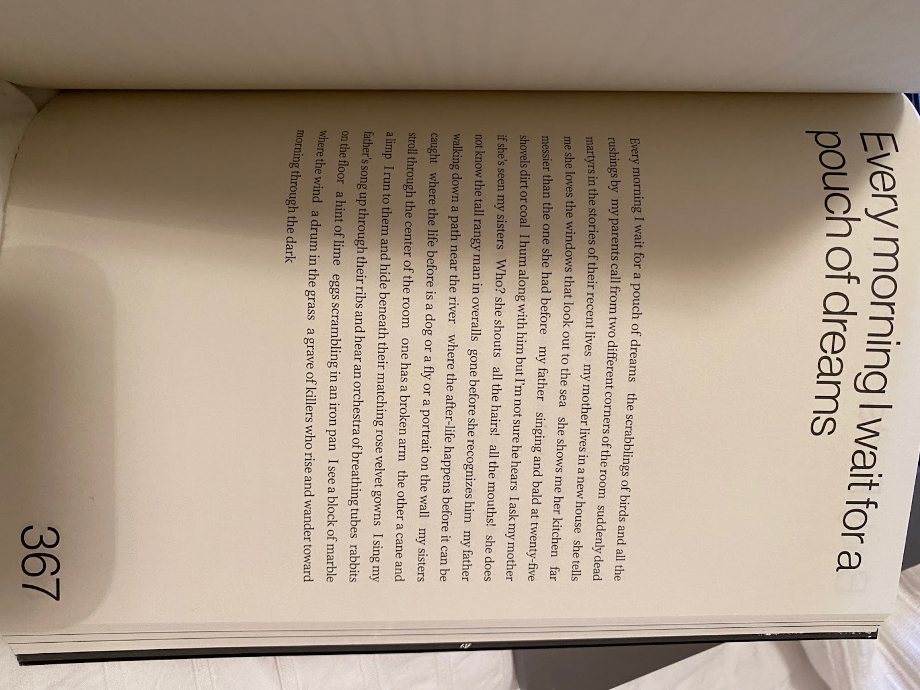
Samuel Ace, from We Want It All: An Anthology of Radical Trans Poetics (2020)

Design a ritual for having a more intentional dream life and encouraging dreams to come, to be remembered. Write the ritual out as a list, a prose poem or a recipe. It might involve: putting something under your pillow, reciting certain phrases or affirmations before sleep, eating something hyper-specific, setting your alarm for specific times in the night to awake and free-write, reading climate journalism before bed, visualising specific landscapes and so on. Think about what kind of worlds you want your dreams to carry, and how to ask for them. Imagine your writing is a kind of pouch for storing the dreams. When do you give them away, when do you withhold them? Reflect on how you can incorporate dream worlds, their sensory encounters and their ethical lessons, into your waking life: think of the two realms as a kind of dialogue.
Workshop feedback (30 mins)

The final part of the workshop is an optional feedback session. I would love to hear some of the poems you’ve written today so we can experience them out as a group and share comments and thoughts. This is not meant to be a formal or technical ‘workshop’ setting so much as a chance to hear each other’s ideas and poetic ventures resonate in the open.

This is another form of social dreaming, where we have the option of baring our conscious and unconscious work: it can be open and there’s no pressure to share if you don’t want to. If you’d like to share a poem raise your hand or post in the chat. After you’ve read the poem, everyone is welcome to share their response in the chat or raise their hand if they’d like to unmute themselves. Please be fair and constructive in your comments: we are more interested in thinking about the poems formally, thematically and conceptually today, as drafts, within the messy possibilities of this workshop, than we are about ‘fixing’ the poem up to something polished and finished.

Good luck with finishing your poems, and submitting to the Ginkgo Prize if you choose to do so!

