The Cute and the Cuddly Worksheet
Ginkgo Ecopoetry Prize

Isabel Galleymore

Introduction

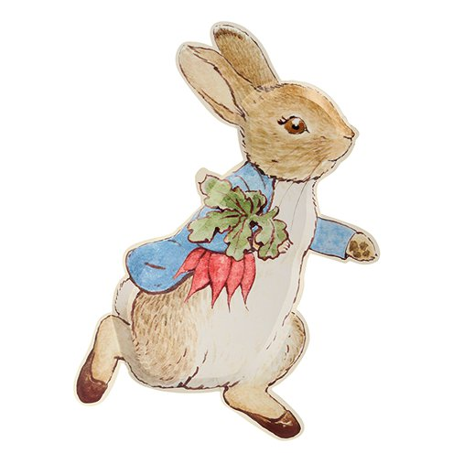
Cuteness pervades our environments. Much of the time, cuteness is a quality observed in (or applied to) animals: a hedgehog-shaped cookie, a pet asleep on the sofa, the logo used by a nature conservation charity, Peter Rabbit-themed home goods and recent trends for ‘flat-nosed’ dogs. As an aesthetic, cuteness associates itself with baby-like features (smallness, roundness, large eyes, softness, stubby limbs), which is intended to trigger a care-giving response in the observer. But, as the examples above suggest, such care-giving is often intercepted by the relationship between cuteness and commodification. Thinking from an ecological point of view, how do we feel about the ways in which cuteness often ‘humanises’ and ‘tames’ the nonhuman through anthropomorphism? What does this mean for our environmental moment: how does cuteness pose both prospects and problems? How can we respond to these questions through ecopoetry? This workshop explores these different enquiries by reading the work of contemporary poets and experimenting with short, playful writing exercises.

Warm-up Exercises

1. Write down as many ‘cute’ words as possible (you might want to include these in your writing later)
e.g. ‘aww’, ‘cotton socks’, ‘oopsie daisy’, ‘honey pie’….

2. Find a cute object in your home (or if there’s nothing to hand, remember an example of cuteness meaningful to you – e.g. a cartoon character). Ask yourself and make notes:
- What makes this object cute?
- How does it make you feel?
- Why is it in your home (or, why is it memorable)?
- Is it representing something that isn’t usually considered cute?
- What words arise when looking or thinking about this object?

Reading 1

Russel Edson
‘Counting Sheep’

A scientist has a test tube full of sheep. He
wonders if he should try to shrink a pasture
for them.
They are like grains of rice.
He wonders if it is possible to shrink something
out of existence.
He wonders if the sheep are aware of their tininess,
if they have any sense of scale. Perhaps they think
the test tube is a glass barn ...
He wonders what he should do with them; they
certainly have less meat and wool than ordinary
sheep. Has he reduced their commercial value?
He wonders if they could be used as a substitute
for rice, a sort of woolly rice . . .
He wonders if he shouldn't rub them into a red paste
between his fingers.
He wonders if they are breeding, or if any of them
have died.
He puts them under a microscope, and falls asleep
counting them . . .

Prompts for discussion:
- What are the implications of having a scientist conduct this experiment?
- How does this poem suggest certain power dynamics involved in cuteness?

Exercise 1
- Choose a subject and imagine making it very small, or, conversely, very big.
- How does your subject relate to its environment?
- How does your subject move? What can it eat? What kind of sound does it make?
- How do you, having shrunk or enlarged your subject, respond to it in comparison to Edson? (What will you do with it? Why did you want to shrink/enlarge it?). Feel free to use a first-person narrator.

Reading 2

Jane Yeh
‘An American Panda Leaves the National Zoo’ (listen to Yeh read it here)

I don’t want to go! Give me another ice lolly
The size of a tyre, with pear chunks in it. I’m too important
To be sent away from my custom-built grotto,
My waterfall and my floofy bedding. There’s a sweet potato

Waiting behind a rock for my long claws to piece it,
Another I hid in a bush for later – I don’t want to go play
With 150 strange pandas in China! Why can’t I stay here
And fondle a leafy stalk! All I want is to flop and loaf

On my belly for hours like a furry hippo. People of Washington,
This is the last time I’ll comically fall off a branch
For you, or get my tongue stuck while licking a fruity tyre,
Or adorably flail my ungainly pancake-like paws

As I lie on my back, unable to get up. Will they have
Webcams in China? I don’t want to live
Like a wild panda, with no one watching. I love
You, rocky outcrop where I clambered as a baby, love

My electronic feeding chute and the llamas next door –
A cranky bunch, but they always look like they’re smiling.
I don’t want to give them up. When spring comes to this time zone
The cherry trees will start to snow, shedding their petals

In a maelstrom of forgetting. Who knows what makes them
Do it? I’ll love them till I die. This is the last place
Where people will speak to me in English, or play popular
Music to see if I’ll dance, or make kissy faces at me

From behind a glass wall. Adios keepers, adios
Observers, adios playful otters, adios haters
(there are always a few). I don’t want to know
about the future. It always gets here, sooner or later.

Prompts for discussion:

- Which parts of this poem command your attention and why?
- Yeh explains that the animal characters she writes are ‘overly anthropomorphised, hence inauthentic. But what’s important to me is trying to access the language of these characters, rather than trying to create “realistic” simulacra.’ What might we stand to learn from amplifying anthropomorphism?

Exercise 2
- Choose a cute subject and speak from its perspective (you might want to choose your object from the warm-up exercises)
- In the style of a dramatic monologue, how does your cute subject feel about being cute?

Conclusion

If there’s time, we’ll have another reading and exercise and I will screen-share these in the session. However, I want to make sure we leave time at the end of the session for sharing of work and conversation. This will be an informal exchange in which you are welcome to raise your hand and read your work or post it in the chat. I look forward to hearing what has come up for you from the readings and exercises!

